**DATA ANALYSIS – DELIVERY 2**

Step 3: Visualize data in Tableau:

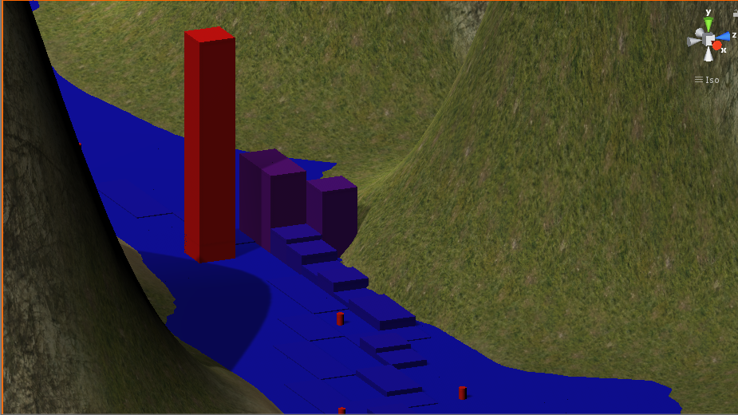We can see our path player in game (HeatMap):

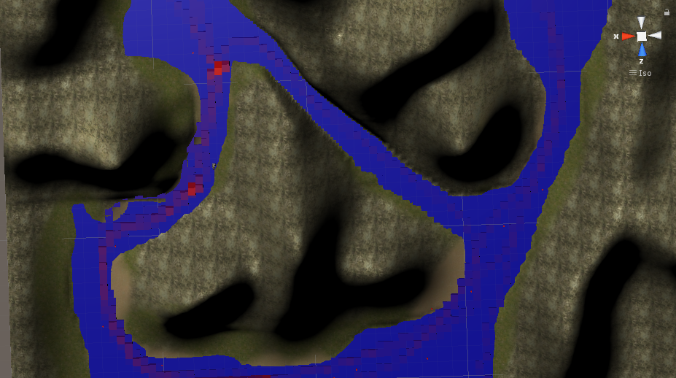

So we have 4 variables: Positions, Sessions, Hits & Rounds.

So for example we can see how many hits the player had per round:



We can see that the player did 4 rounds and had 1 hit per round.

In the following example we are computing number of rounds per session. So we can check that everybody completes the first round. But none of them complete the 4th.

